Method 1: Flash software is burned on the computer (without IDF development environment).

Currently, Xiaozhi AI firmware is suitable for ESP32 series main control chip development boards, please refer to the firmware download comparison table for details.

Note: 1) v0. X.X_ML307.zip is the 4G version firmware, please download v0 for the default WiFi version. X.X_bread-compact-wifi.zip (x.x stands for version number).
2) This document is an example of firmware programming operation, and it is recommended to burn the latest firmware version during burning.
Install the Flash downloader：https://www.espressif.com.cn/zh-hans/support/download/other-tools。
Or directly download the following compressed package, unzip and open it to download the tool:
This content is only supported in a Feishu Docs
Connect the USB JTAG/serial of the ESP32 S3 development board to the computer host, run the Flash download tool, and use UART mode to download and unzip the merged-binary.bin Burn to address 0x0.
- Preparation
On Windows system, Flash download_tool version 3.9.7 is recommended for downloading/burning tools, and other versions can be used as long as they are not too old.
After downloading, unzip flash_download_tool_3.9.7_1.zip to the hard disk and specify the directory by yourself, no need to install, enter the directory and double-click flash_download_tool_3.9.7.exe to run.
Note that the burning tool should not be placed in the Chinese directory, otherwise the file may not be loaded.
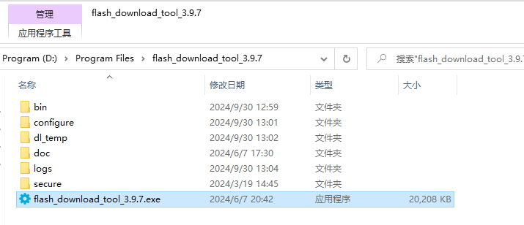
- Download the firmware

（1）Download and unzip

Click to open the firmware list: v1.5.5 Xiaozhi AI Terminal latest version firmware download

Note: When downloading and storing on my computer's local hard drive, it is recommended not to contain Chinese characters in the path, otherwise the burning may not be loaded.  The following figure is for example reference only, please download the latest firmware version for specific operations.  Please select the corresponding version to download the firmware to the local hard drive of your computer according to the development board and peripheral modules you are using.  Note: bread starts with breadboard firmware (purchased by yourself ESP32s3-WROOM-1/1U-N16R8 development board and module assembly, according to the wiring scheme, use breadboard, Dupont cable or self-soldering), the default selection is the WIFI version, if the ML307R (AT) is installed, For 4G modules, please select the ML307 version.  Breadboard wifi product correspondence: vx.x.x_bread-compact-wifi.zip  The 4G version of the breadboard corresponds to vx.x.x_bread-compact-ml307.zip (vx.x.x indicates the version number, e.g. v1.5.5).  The firmware corresponding to the development board/product is displayed in pinyin in Chinese or corresponding in English (please note), please refer to the figure below  Note: Please select the corresponding firmware program to program programming (vx.x.x indicates the version number, such as v1.5.5), if you select the wrong program, it may not run and the screen will not be displayed. For the development board you don't understand, please consult the seller or search online.  serial number | Development board/product type | Firmware BIN package (vx.x.x indicates the version number, e.g. v1.5.5)
1 | Breadboard New Wiring (WIFI) 0.91OLED (44 or 42-pin esp32s3-wroom-1 development board)  BOARD_TYPE_BREAD_COMPACT_WIFI | vx.x.x_bread-compact-wifi.zip
2 | Breadboard new version wiring (WIFI) + LCD (44 or 42-pin esp32s3-wroom-1 development board)  BOARD_TYPE_BREAD_COMPACT_WIFI_LCD | Please compile the firmware according to the LCD screen resolution yourself
3 | The new version of the breadboard is wired（ML307 AT）  BOARD_TYPE_BREAD_COMPACT_ML307 | vx.x.x_bread-compact-ml307.zip
4 | ESP BOX 3 （Espressif）  BOARD_TYPE_ESP_BOX_3 | vx.x.x_esp-box-3.zip
5 | Kevin Box 1  BOARD_TYPE_KEVIN_BOX_1 | vx.x.x_kevin-box-1.zip
6 | Kevin Box 2  BOARD_TYPE_KEVIN_BOX_2 | vx.x.x_kevin-box-2.zip
7 | Kevin C3  BOARD_TYPE_KEVIN_C3 | vx.x.x_kevin-c3.zip
8 | Kevin SP V3Development board  BOARD_TYPE_KEVIN_SP_V3_DEV | vx.x.x_kevin-sp-v3.zip
9 | Lichuang·Practical ESP32-S3 development board  BOARD_TYPE_LICHUANG_DEV | vx.x.x_lichuang-dev.zip
10 | Lichuang and practical ESP32-C3 development board  BOARD_TYPE_LICHUANG_C3 | vx.x.x_lichuang-c3-dev.zip
11 | Magic button Magiclick_2.4  BOARD_TYPE_MAGICLICK_2P4 | vx.x.x_magiclick-2p4.zip
12 | Magic button Magiclick_C3  BOARD_TYPE_MAGICLICK C3 | vx.x.x_magiclick-c3.zip
13 | M5Stack CoreS3  BOARD_TYPE_M5STACK CORE S3 | vx.x.x_m5stack-core-s3.zip
14 | AtomS3 + Echo Base  BOARD_TYPE_ATOMS3_ECHO_BASE | vx.x.x_atoms3-echo-base.zip
15 | AtomS3R + Echo Base  BOARDTYPE_ATOMS3R_ECHO_BASE | vx.x.x_atoms3r-echo-base.zip
16 | AtomMatrix+ Echo Base  BOARDTYPE ATOMMATRIX ECHO BASE | vx.x.x_atommatrix-echo-base.zip
17 | Brother Shrimp Mini C3  BOARD TYPE_XMINI_C3 | vx.x.x_xmini-c3.zip
18 | ESP32S3 KORV02 V3Development board  BOARDTYPEESP32S3_KORV02_V3 | vx.x.x_esp32s3-korvo2-v3.zip
19 | ESP-SparkBot Development Board (Tank)  BOARD_TYPE_ESP SPARKBOT | vx.x.x_esp-sparkbot.zip
20 | Waveshare ESP32-S3-Touch-AMOLED-1.8(Light snow)  BOARD_TYPE_ESP32S3_Touch_AMOLED_1_8 | vx.x.x_esp32-s3-touch-amoled-1.8.zip
21 | Waveshare ESP32-S3-Touch-LCD-1.85C  BOARD_TYPE_ESP32S3_Touch_LCD_1_85C | vx.x.x_esp32-s3-touch-lcd-1.85c.zip
22 | Waveshare ESP32-S3-Touch-LCD-1.85  BOARD_TYPE_ESP32S3_Touch_LCD_1_85 | vx.x.x_esp32-s3-touch-lcd-1.85.zip
23 | Waveshare ESP32-S3-Touch-LCD-1.46  BOARD_TYPE_ESP32S3_Touch_LCD_1_46 | vx.x.x_esp32-s3-touch-lcd-1.46.zip
24 | LILYG0 T-Circle-S3  BOARD TYPE LILYGOTCIRCLE S3 | vx.x.x_lilygo-t-circle-s3.zip
25 | Movecall Moji Ash AI derivative version  BOARD TYPE MOVECALL MOJI ESP32S3 | vx.x.x_movecall-moji-esp32s3.zip
26 | Punctual Atom DNESP32S3 development board BOARD_TYPE_ATK_DNESP32S3 | vx.x.x_atk-dnesp32s3.zip
27 | Punctual Atom DNESP32S3-BOX  BOARD_TYPE_ATK_DNESP32S3_BOX | vx.x.x_atk-dnesp32s3-box.zip
28 | Breadboard New Wiring (WIFI) 0.96 OLED Screen (44 or 42 Pin ESP32S3-Wroom-1 Development Board)  BOARD_TYPE_BREAD_COMPACT_WIFI | vx.x.x_bread-compact-wifi-128x64.zip
29 | Breadboard New Wiring (ML307 AT) 0.96 OLED Screen (44 or 42-Pin ESP32S3-WROOM-1 Development Board)  BOARD_TYPE_BREAD_COMPACT_ML307 | vx.x.x_bread-compact-ml307-128x64.zip
30 | Development Board CHATX (wifi)  BOARD_TYPE_DU_CHATX | vx.x.x_du-chatx.zip
31 | Tai Chi Xiaopai esp32s3 BOARD_TYPE_ESP32S3_Taiji_Pi | vx.x.x_taiji-pi-s3.zip
32 | Anonymous Technology Star Intelligence 0.96 BOARD_TYPE_XINGZHI_Cube_OLED | vx.x.x_xingzhi-cube-oled.zip
33 | Anonymous Technology Star Wisdom 1.54  BOARD_TYPE_XINGZHI_Cube_TFT | vx.x.x_xingzhi-cube-tft.zip
Note: Other development boards or products do not have default support, the direct programming program may not run, and the source code of the program needs to be modified to recompile to adapt to the chip pin interface and related audio drivers. (These operations require setting up the ESP-IDF development environment first, and being familiar with the source code before modifying and compiling, which is not explained in this document.) ）
In the following example, select the v1.5.5-bread-compact-wifi.zip version of the firmware and extract it to get a merged-binary.bin file.
Latest firmware address: Xiaozhi AI terminal latest version firmware download
Use the breadboard plug to download the WIFI version by default, and ML307 is the 4G version firmware.

(2) Copy the .bin file to the specified directory
It is recommended to unzip the downloaded bin firmware package file and put it in the bin directory of the Flash Download Tool software, please do not use the Chinese directory name, as shown in the figure below
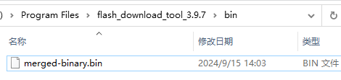

（3）other
Other releases firmware versions and source code files are below, and you can choose to download them according to your needs.

- Burn firmware/download to the board
到 Flash download_tool_3.9.7 解压后目录，双击运行 flash_download_tool_3.9.7.exe 如下图示：

1）Download the settings
（1）For the chip type, ESP32S3 development board please select ESP32-S3, if the user development board is ESP32 series other chips, please select the corresponding chip type ChipType, for example For ESP32-C3 development boards/products, please select ESP32-C3.
(2) Working mode, select Develop
(3) Loading mode, it is recommended to select UART (alternative USB mode, not explained here).
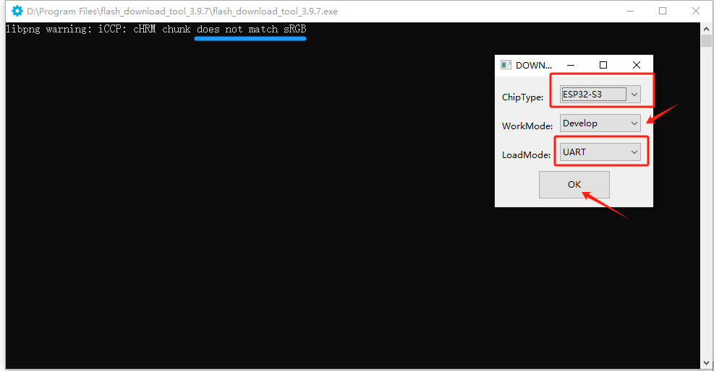

Interface and sRGB etc. description:
(1) When the TypeC interface on the front of the development board is facing down, the right interface is the UART interface (as shown in the figure below), and the left interface is the USB interface.
Supplement: Individual customized development boards may be different, please identify them as UART interfaces according to the silk screen COM on the front or back of the USB interface of the development board.
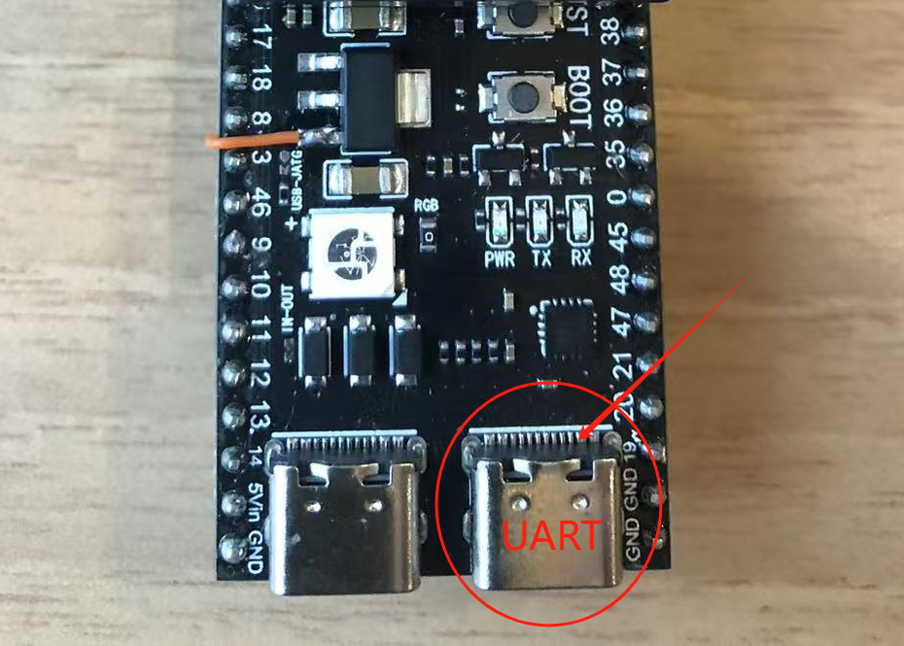
(2) If the switch of the sRGB lamp on your development board is not soldered (some manufacturers consider that some people may not need to use sRGB lamps), the Flash download tool will not recognize it and a warning will appear, which will not affect the burning, you can ignore it first, and then use the electric iron to short it (see position 2 at the bottom).

2) Load the firmware & SPI download settings
(1) On the blank box in the first line ... button, select the bin file directory to import the bin file, as shown in the figure below
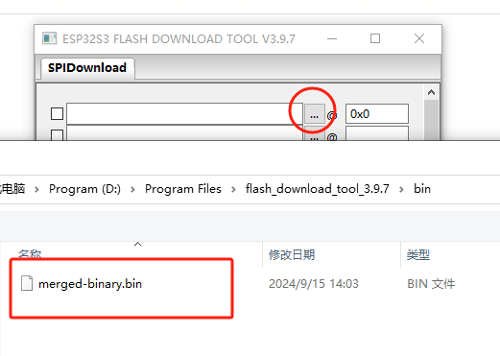
(2) Check in front of the import bin file selection box (be sure to check it), and fill in 0x0 or 0x00 or 0 in the input box behind the bin file selection box (indicating that it is downloaded to the starting position of the development board memory area 1). ）

Note: If you do not put the bin file in the bin directory of the flash download tool program, please do not use the Chinese directory name when you put it in other places on the computer hard drive, otherwise the burning program will load the bin file will report an error and will not be able to be burned.

(3) COM port: First on the desktop This computer —" right-click menu Properties —" Device Manager (right menu) - " Ports (COM and LPT Click to expand to view the COM port number corresponding to the inserted development board, (if you are not sure, please plug and unplug the USB interface of the development board, see that the uninstalled and newly recognized COM port number is the COM port number to be selected), that is, the FLASH DOWNLOAD TOOL in SPI download is the corresponding COM port number to be set.

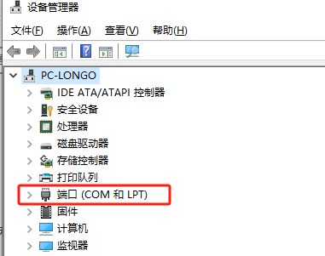
Note: The COM serial port of ESP32S3 development board is generally CH340 or CH343 chip-driven, with CH34 ports, or individual CP210 and other chip-driven , as wellUART port.
The following figure shows the COM8 port here for reference only, according to the COM port displayed on your computer to choose your development board port, not necessarily COM8, subject to the COM port identified by your computer.
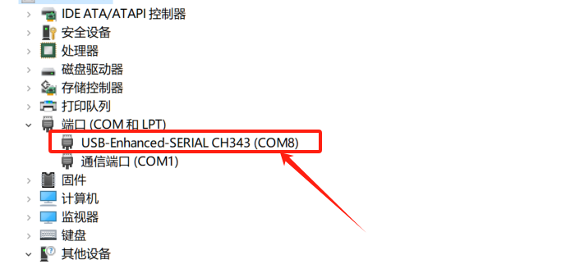
(3) Others: SPI speed SPEED and SPI mode MODE can be defaulted (do not choose QOUT and DOUT), and the BAUD baud rate can be selected at a higher speed.
** Be sure to check the box in front of the burned bin file!
** The COM port number is selected according to the COM port in your computer device manager (not necessarily COM4, the figure below is for demonstration only).

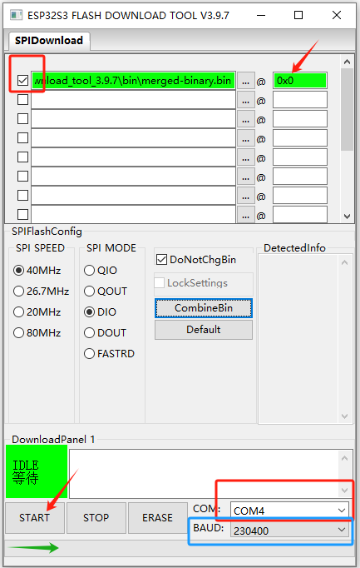
(4) Click START to start burning, the progress bar will start to appear until it ends, and the status shows FINISH completed. The download/burning process is generally a few minutes to ten minutes. Download complete as shown below
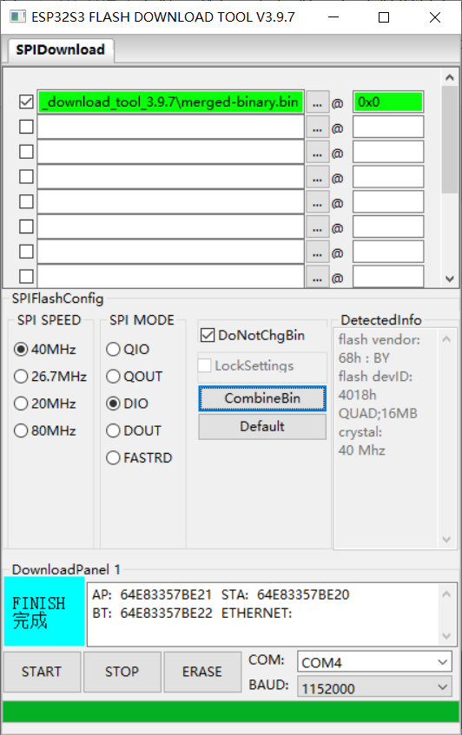

(5) After the burning is completed, click RST (Restart) on the button to restart the development board to enter the WI-FI distribution mode.
Provisioning and Enrollment Device Links: How to configure device Wi-Fi and enroll devices
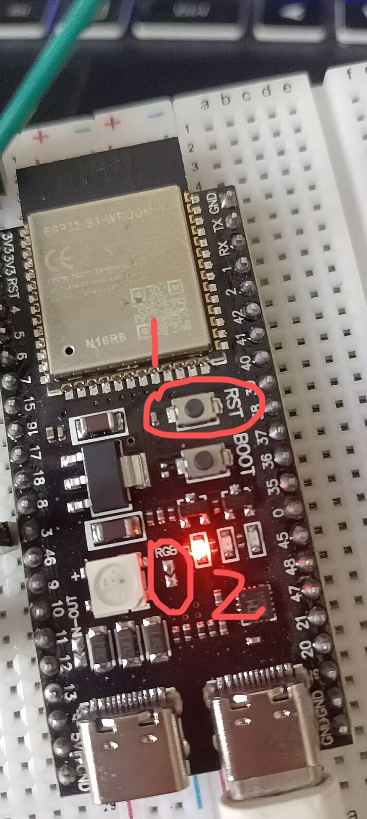

Method 2: Third-party Xiaozhi special firmware web-side online burning tool

- Xiaozhi AI firmware special programming tool - Ludaima IoT one-stop development tool
Note: For a better experience, please use the Edge browser to access. Support WeChat scan code login and account login.
https://dev.16302.com/tools/xiaozhiinit
The preview of the burning homepage is as follows:
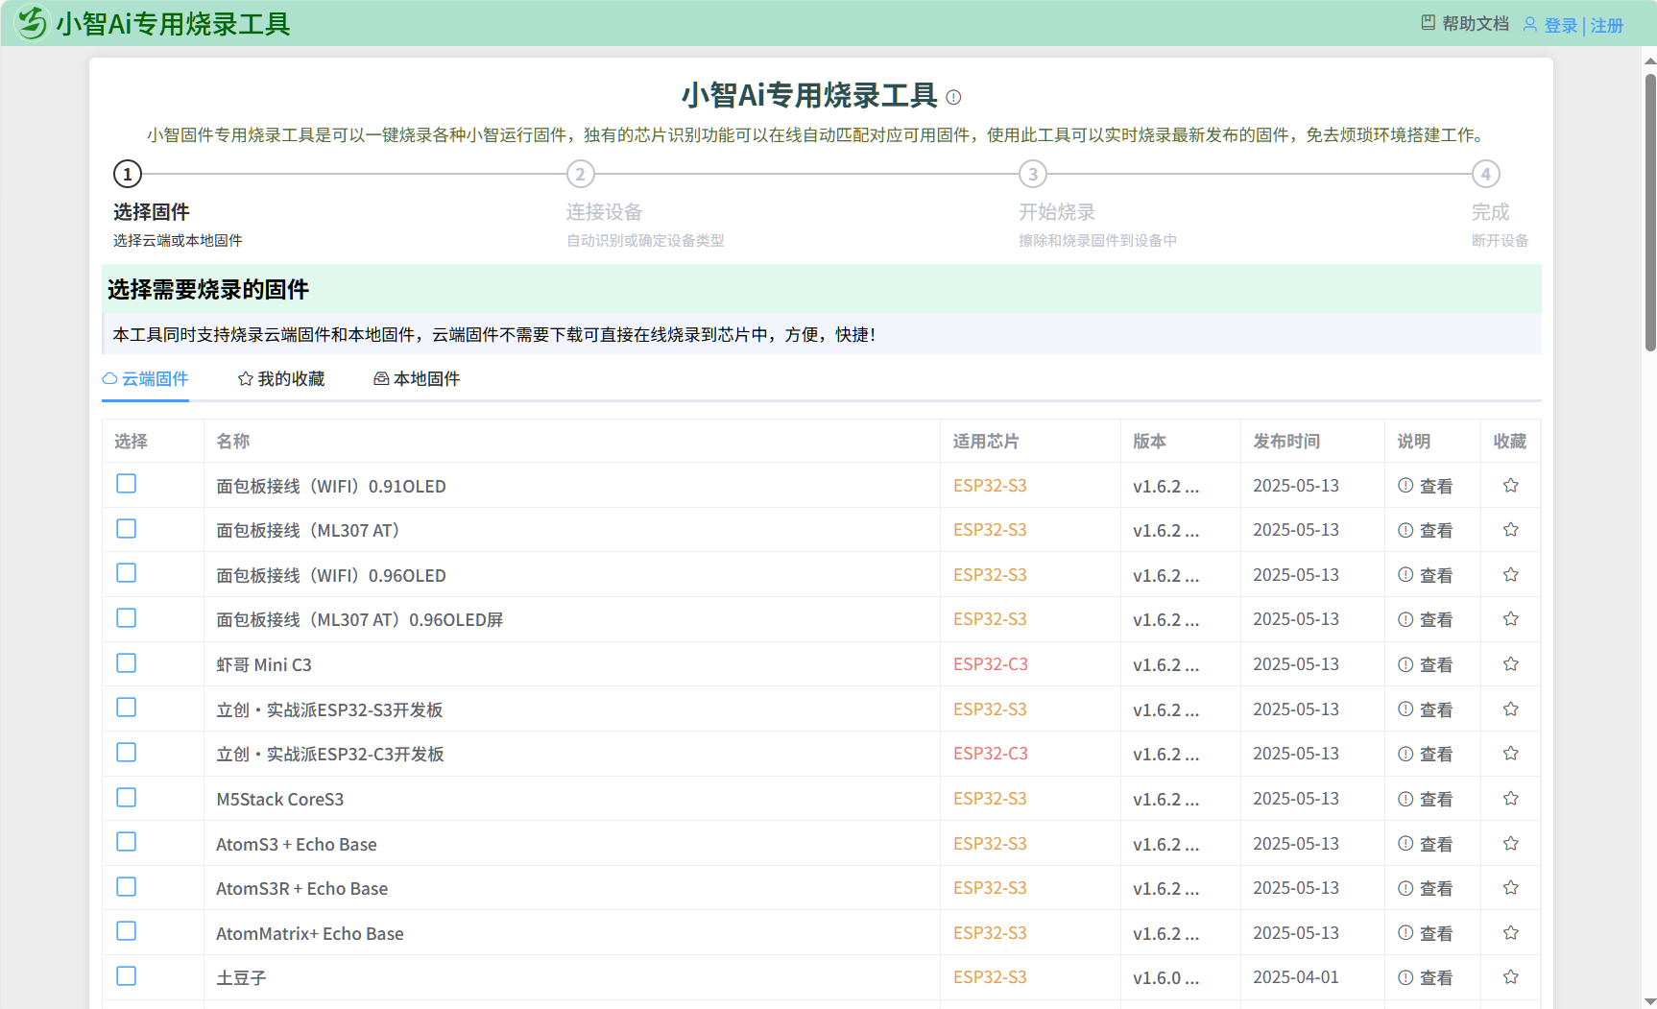

The special programming tool for Xiaozhi firmware is a one-click programming of various Xiaozhi running firmware, and the unique chip recognition function can automatically match the corresponding available firmware online.

The main steps are as follows:

1.1 Select firmware
Choose between cloud or on-premises firmware
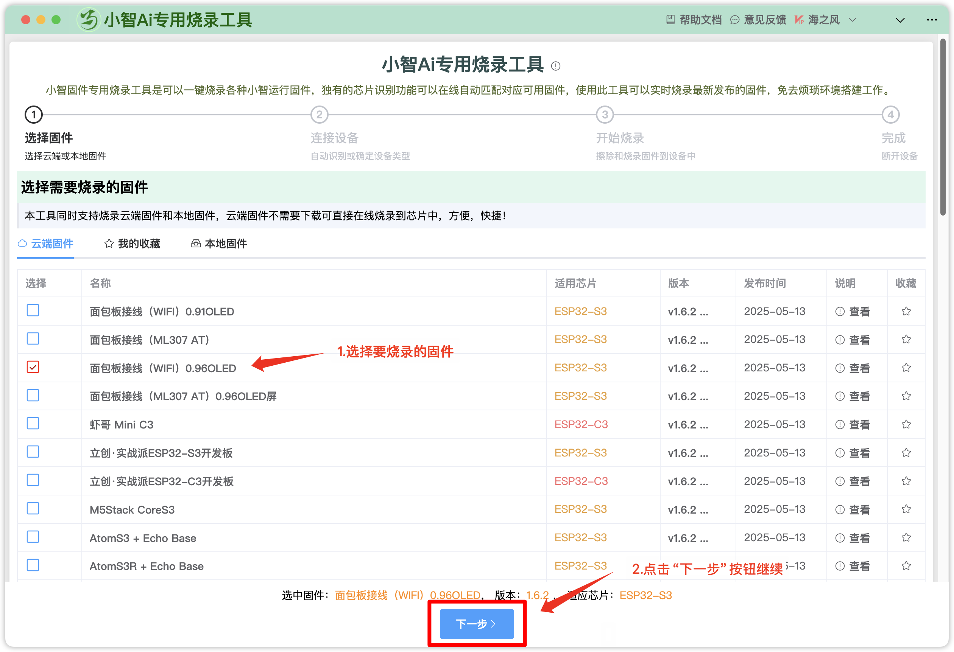

1.2 Connect devices
Automatically identify or determine the type of device
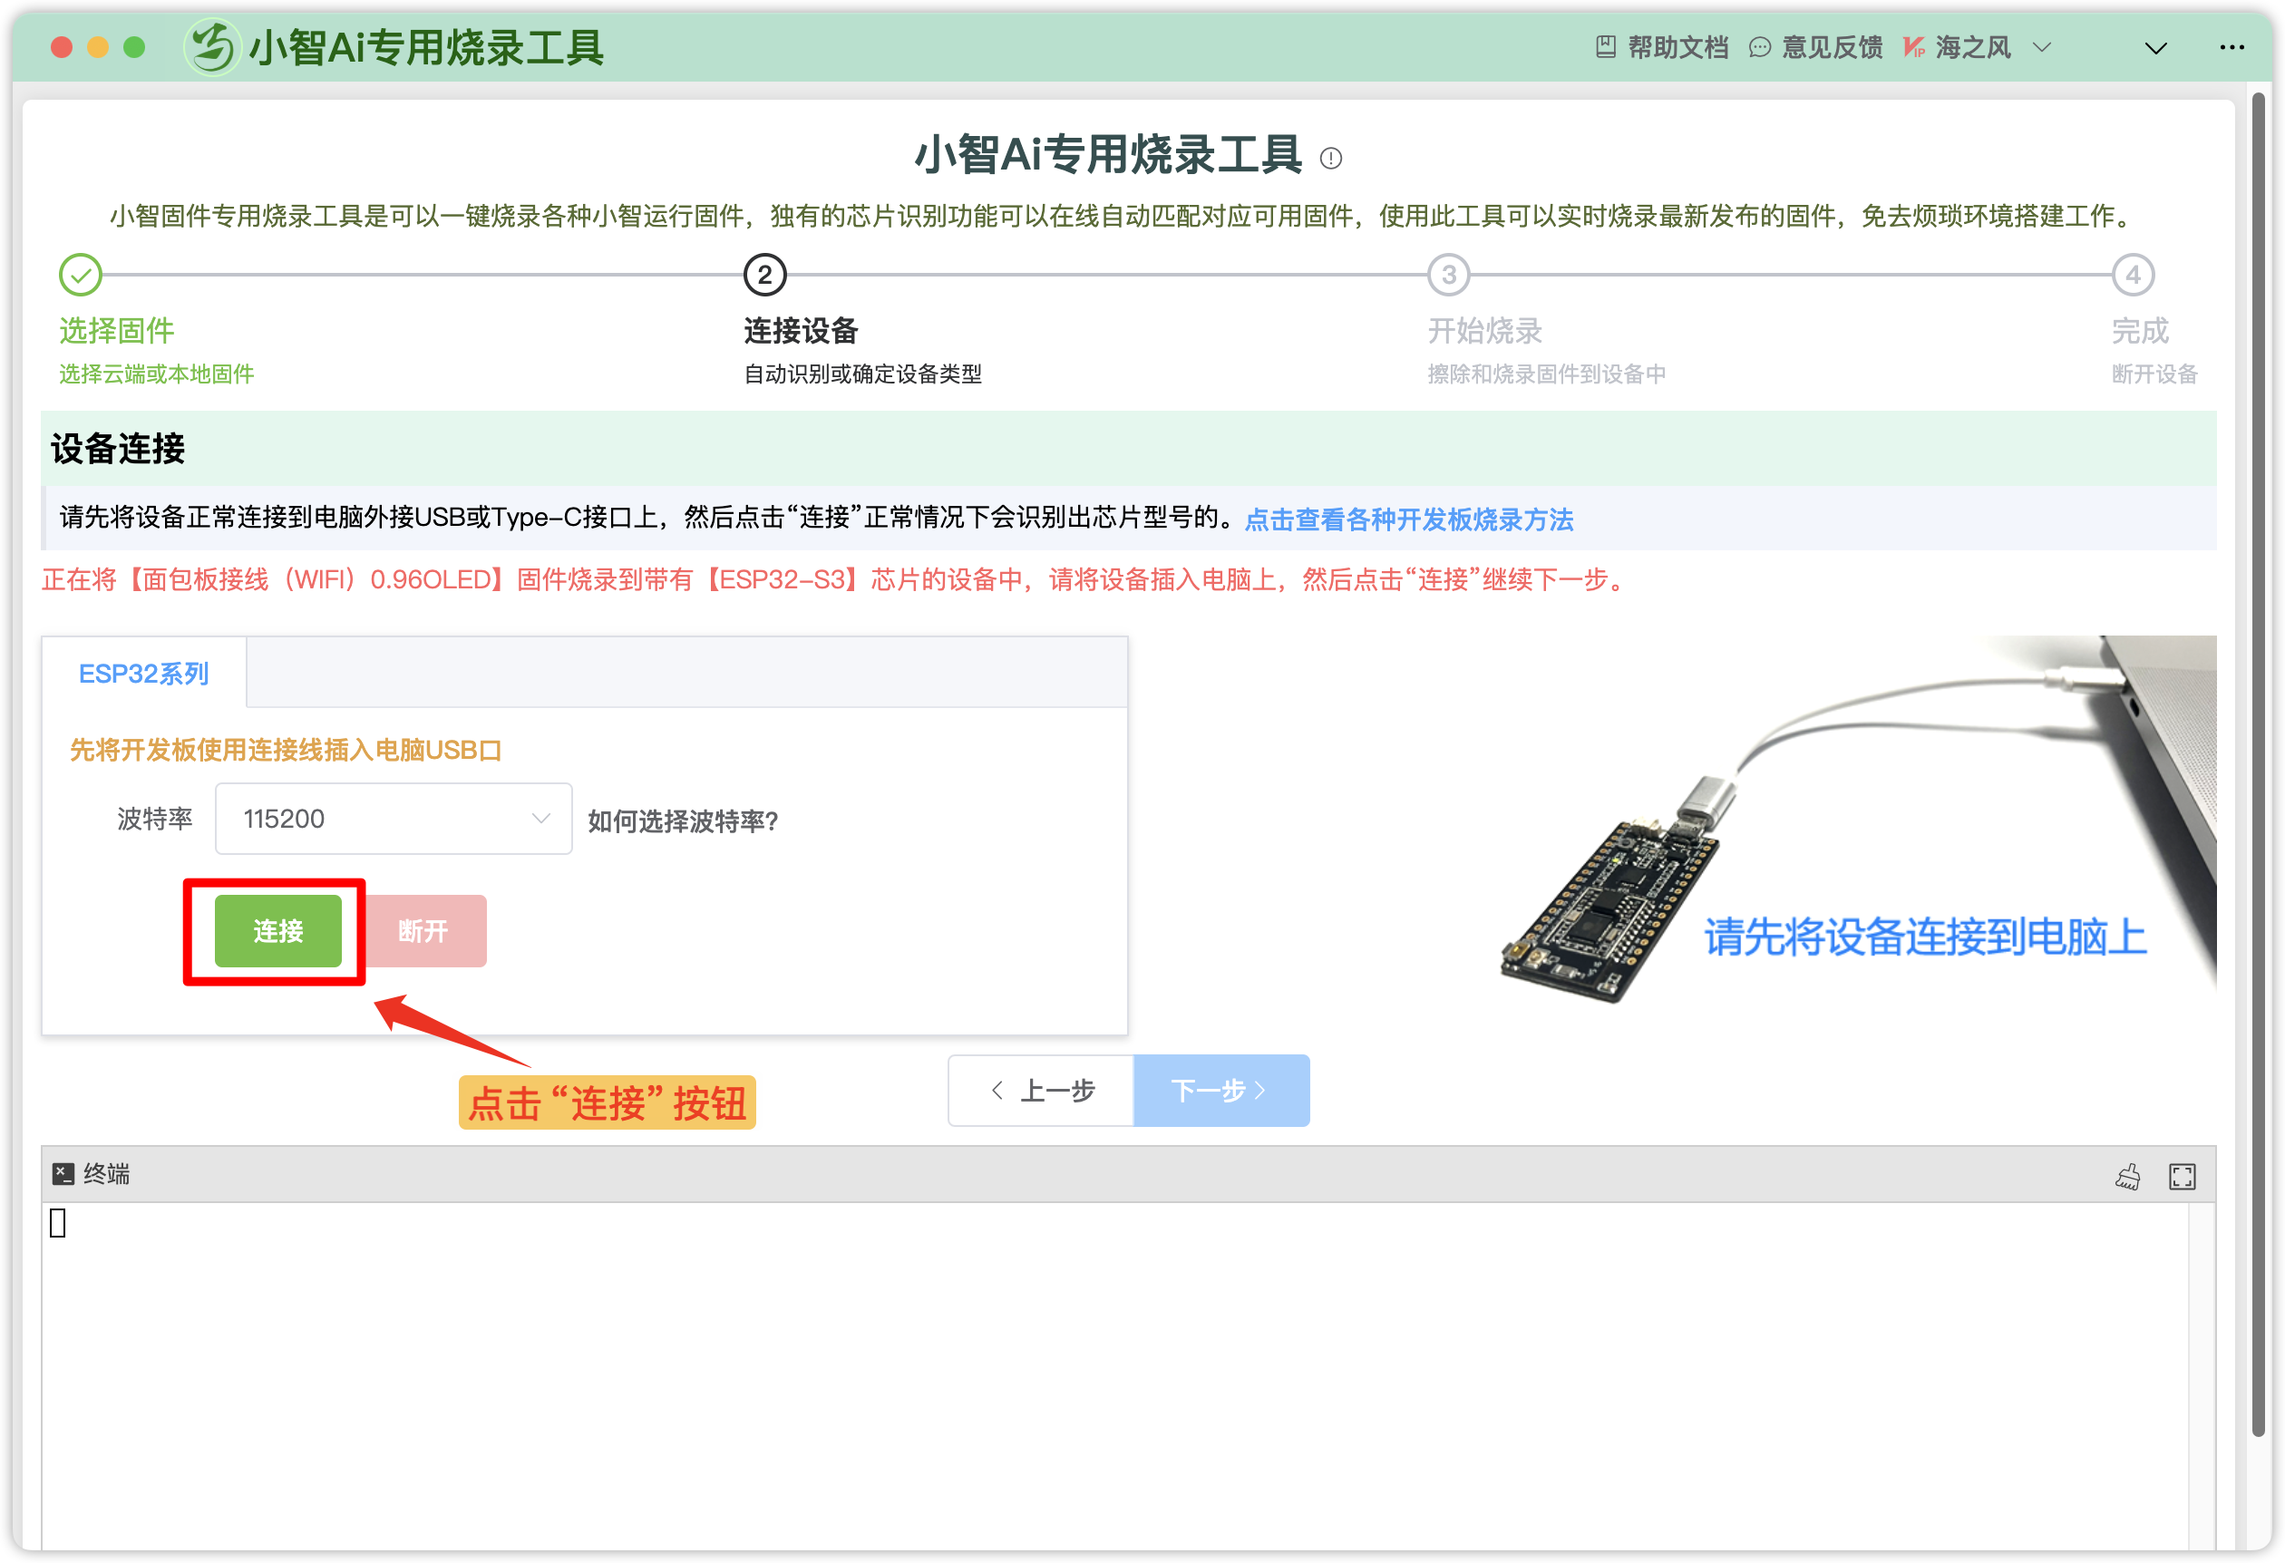

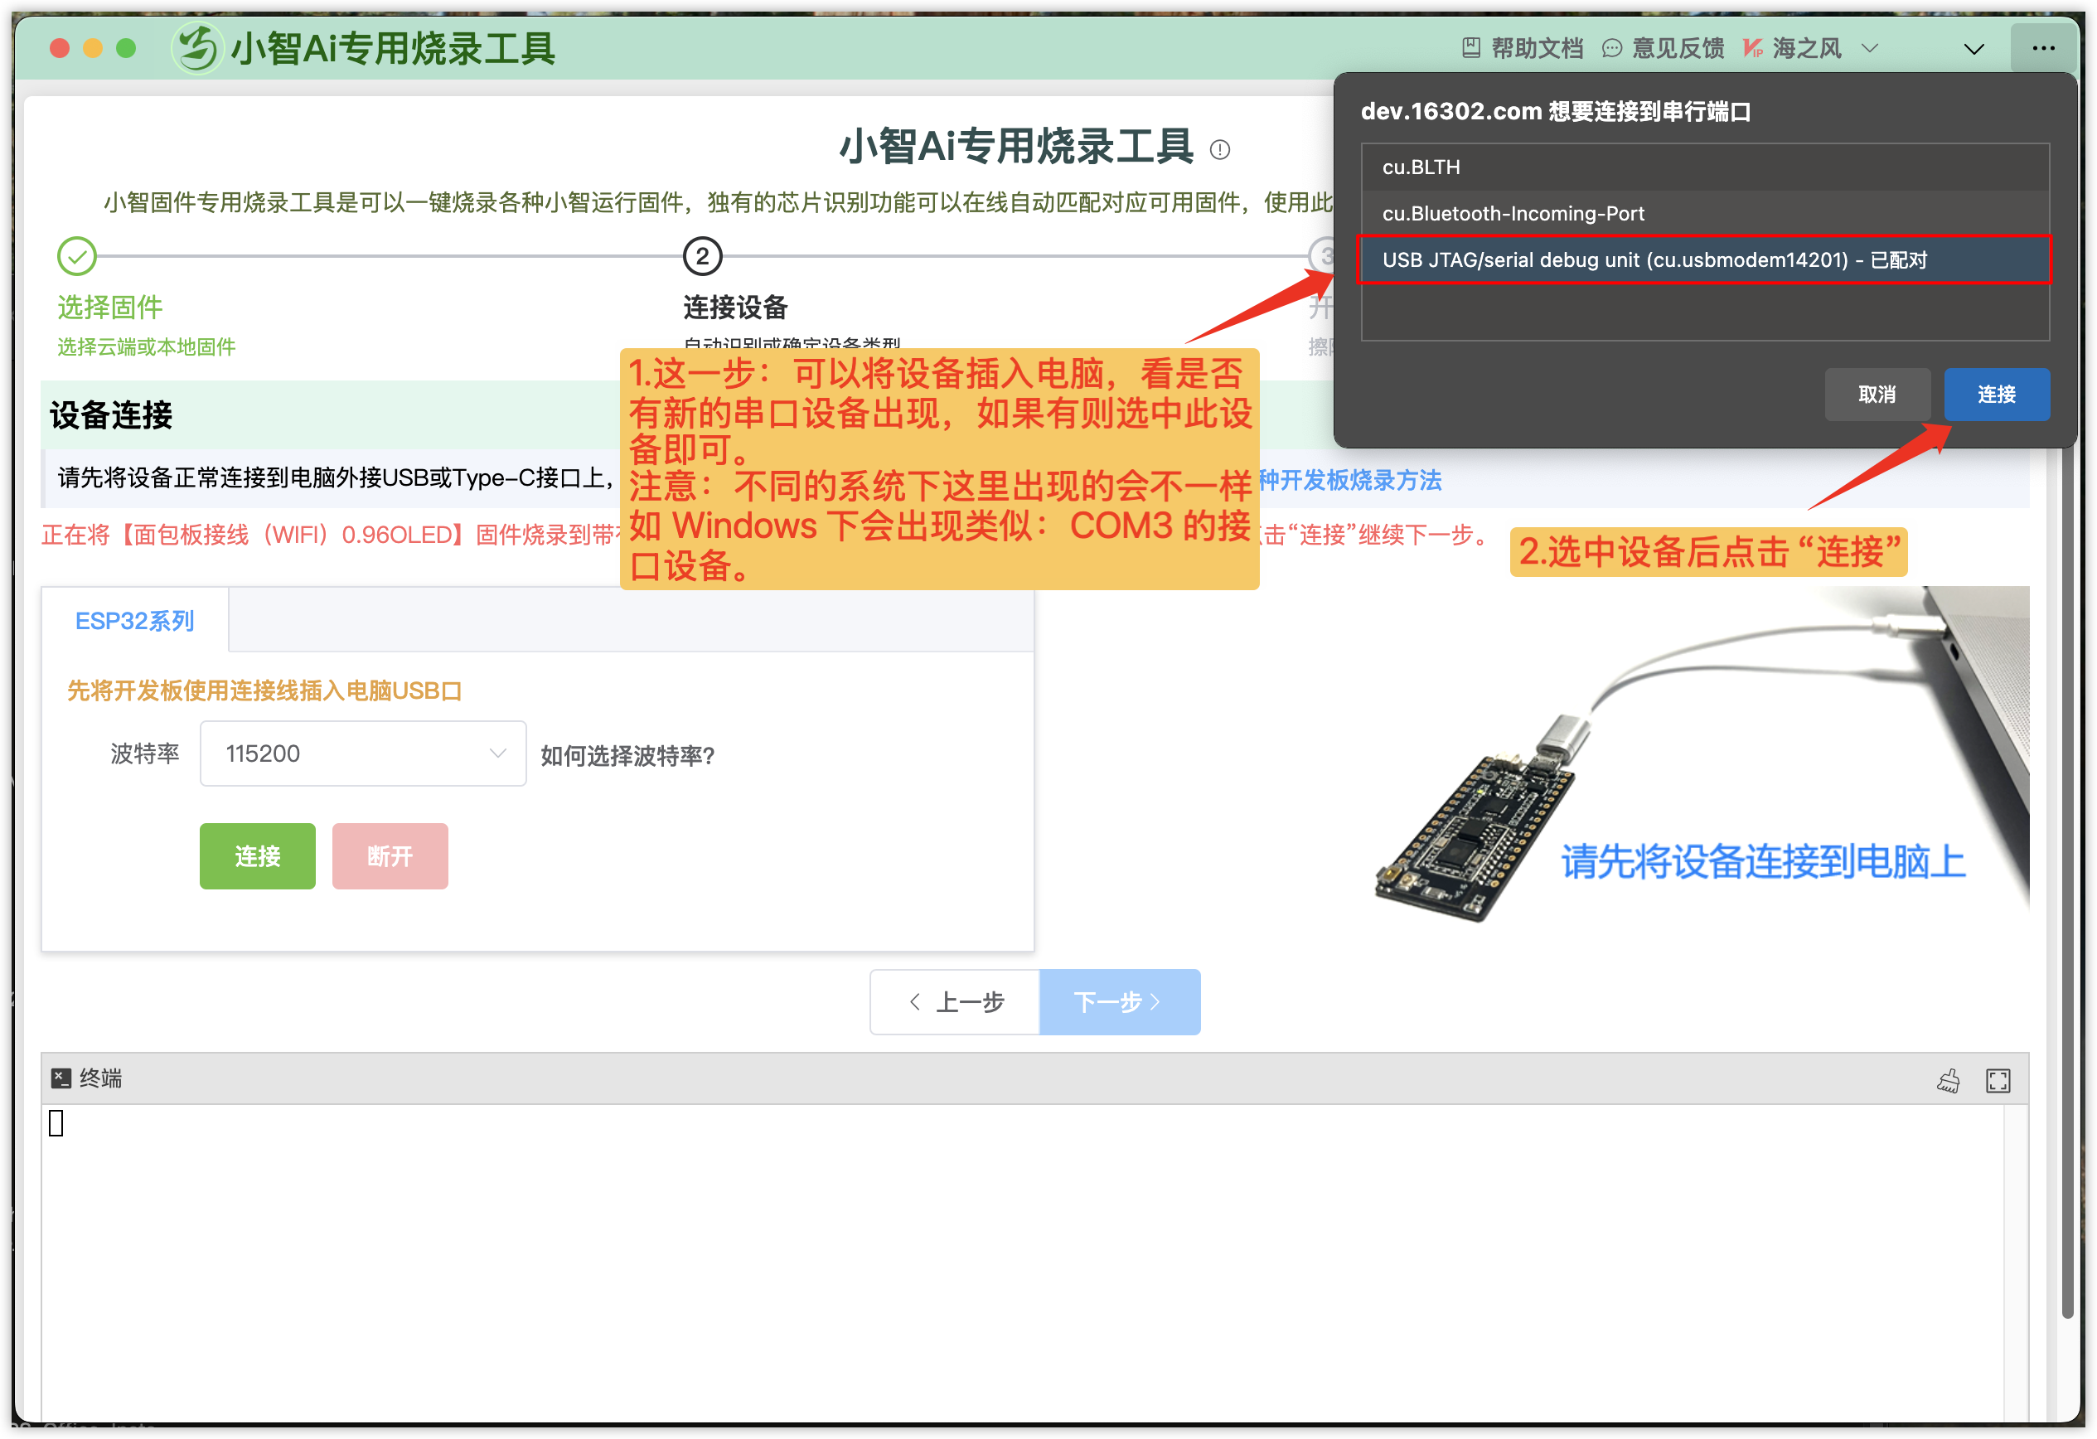

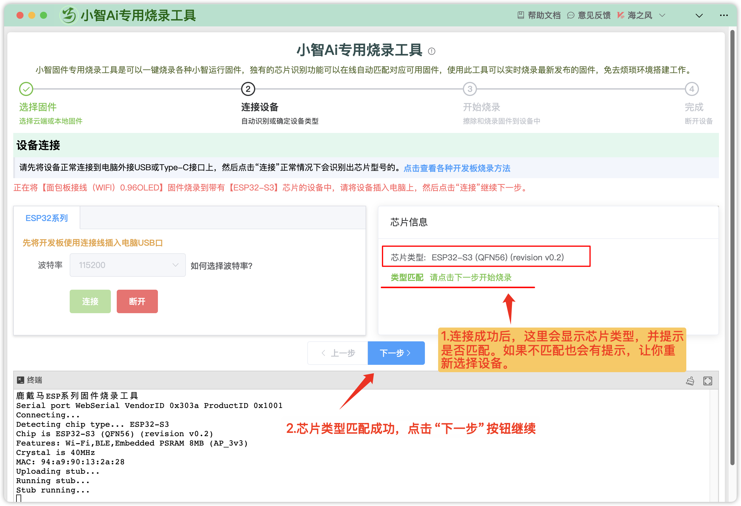

1.3 Start Burning
Erase and burn firmware into the device
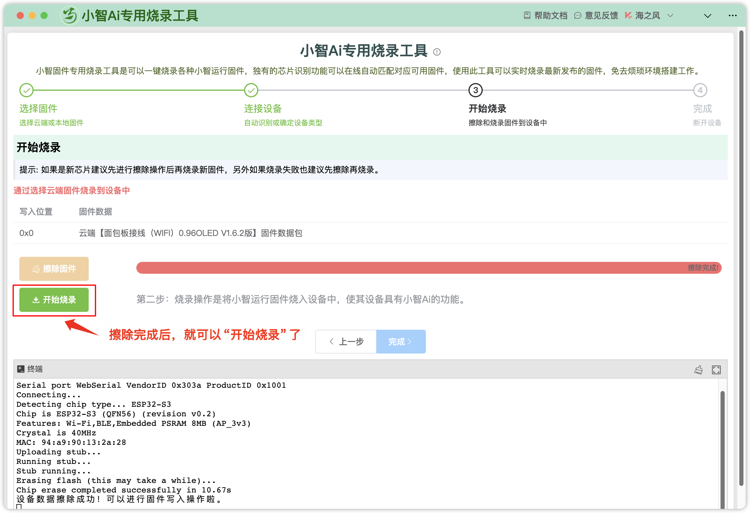
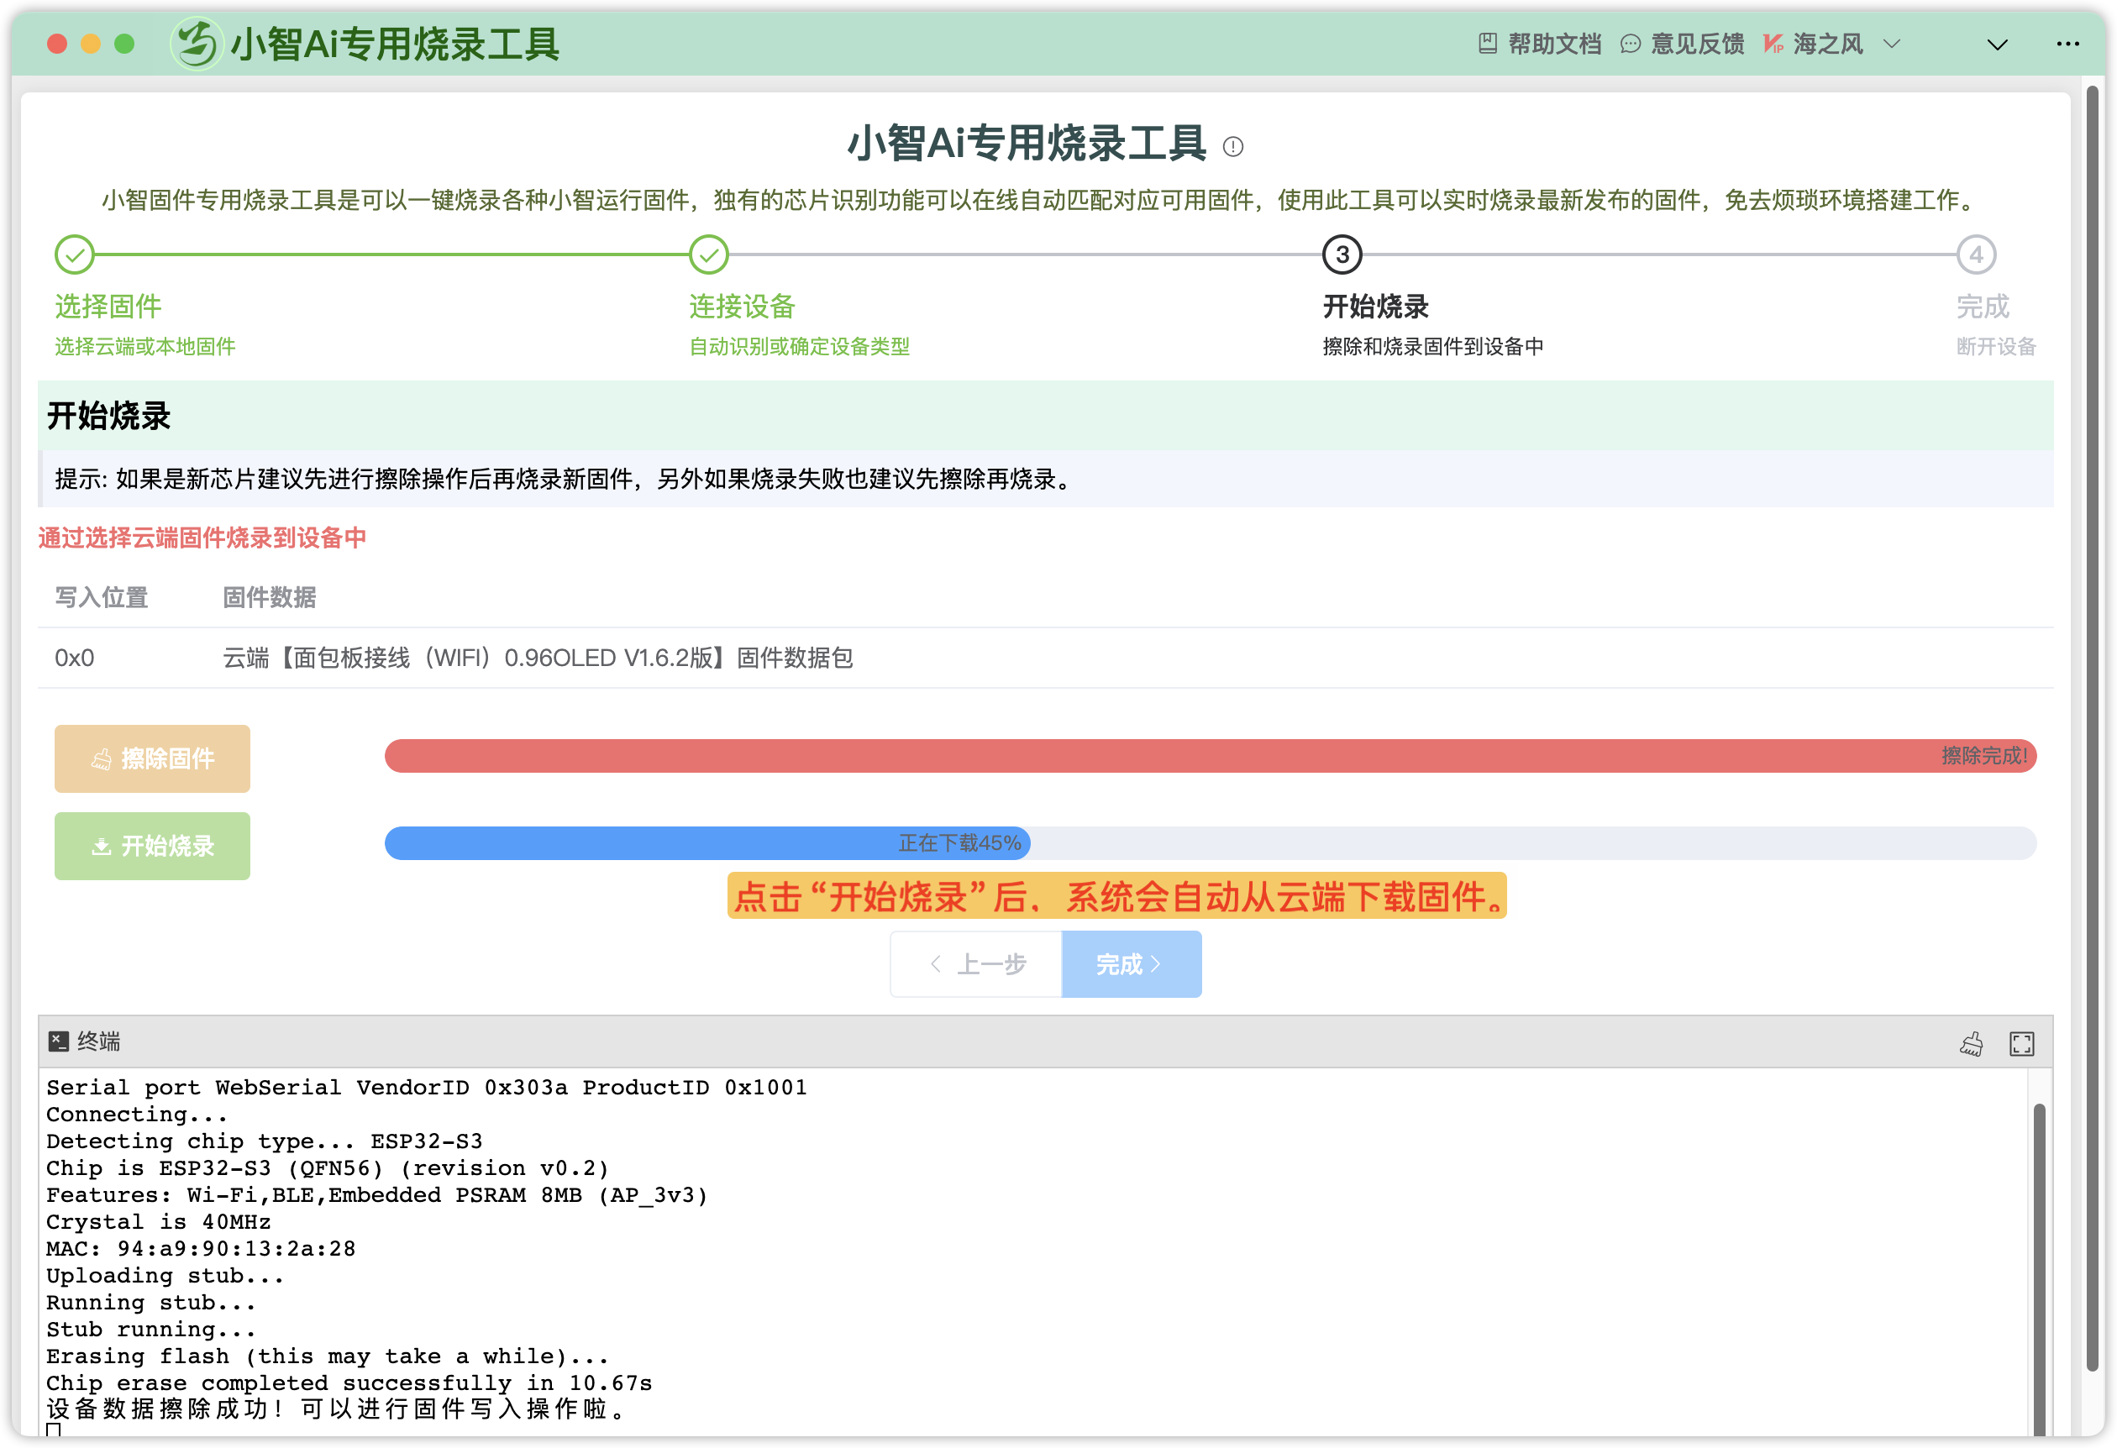

1.4 finish
When the burning is complete, the device is prompted to be disconnected. Return or enter the terminal test device.
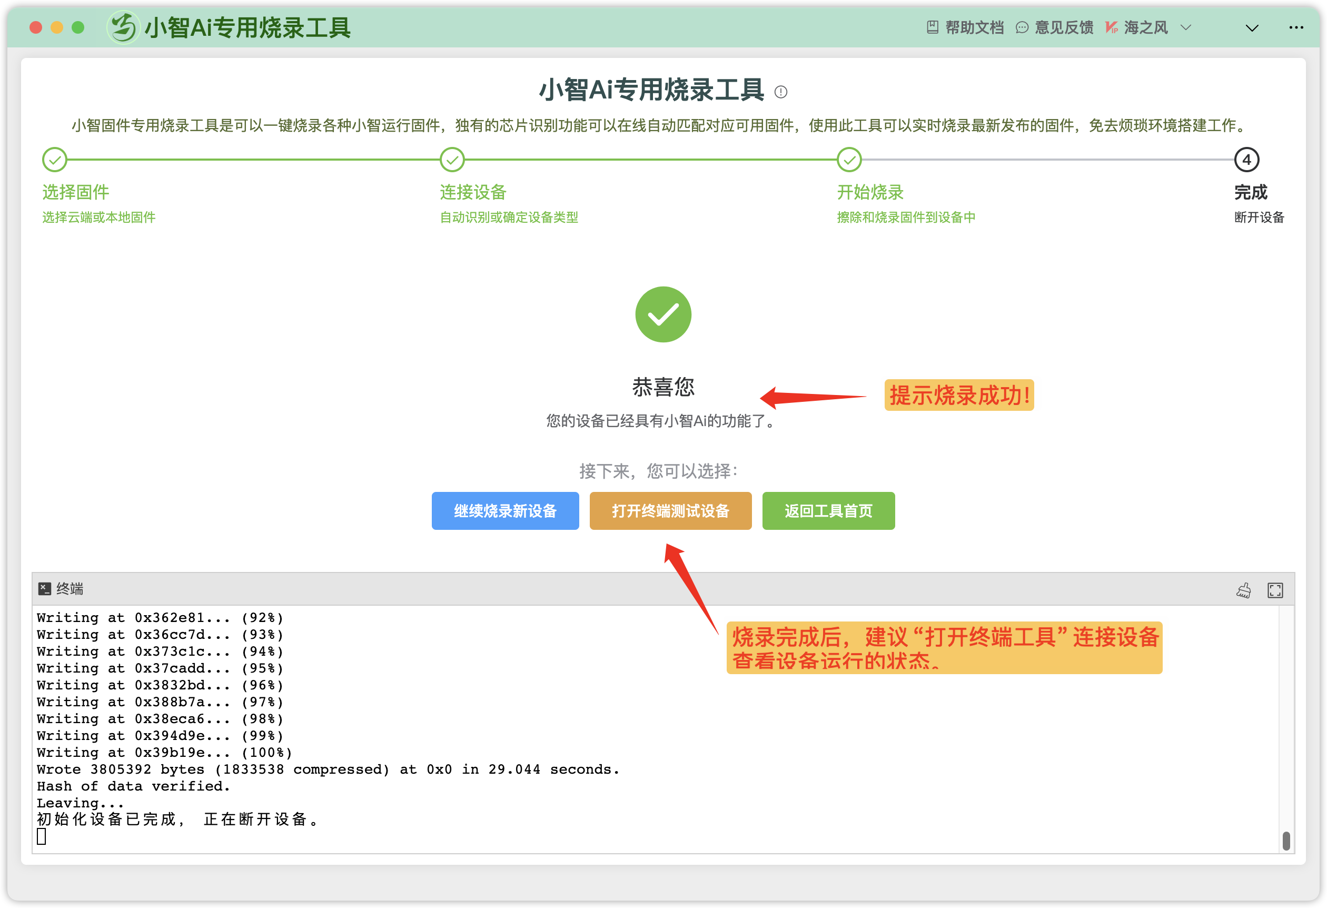

Method 3: ESP-Launchpad browser WEB burning

- Preparation
1) Prepare the ESP32S3 development board to be burned, please refer to the supported development board in the download firmware paragraph in Method 1 above.
2) Data cable connected to the development board (standard data cable configured in mobile phones or development boards, etc., cannot be the USB charging cable for ordinary electronic products with 2 cores).
A computer desktop or laptop with a USB port with Internet access.
3) Please connect the ESP32S3 development board to the USB interface of the computer (some development boards need to turn on the power switch), and make sure that the COM serial port has been recognized in the computer - right-click Properties - Related Settings - Device Manager 。
If the COM port is not found, please check the status of the data cable and the development board, and confirm that the serial bridge chip driver has been installed (the driver can be asked by the seller or searched on the Internet), if you are not sure which COM port it is, please refer to Section 3 of Method 1 Plug and Plug Identification, etc.
4) Please use mainstream browsers, such as Google Chrome (verified), Wesoft Edge (verified)/IE browser, or other webkit kernel browsers. Try not to use computer management software and antivirus software when burning firmware.

- Download the firmware
Download the firmware version of Xiaozhi AI to the computer hard drive, extract the bin firmware file for later use.
Users who assemble the Ash AI terminal on the breadboard should download the WiFi version v0 by default. X.X_bread-compact-wifi.zip (x.x stands for version number).
Please do not use the Chinese directory/path, please refer to Section 2 of Method 1 above.
Firmware address: v1.5.5 Xiaozhi AI terminal latest version firmware download

- Burn firmware/download to the board

1) Browser access to the burning URL
Online burning of URLs:https://espressif.github.io/esp-launchpad/

If you see that there is no following, it is that the administrator may be editing, click the link above to study it first. Or wait for me to finish writing.

The programming website used in this tutorial is in English, and the homepage is an introduction to the firmware function of the programming application. The website quick start page defaults to the application firmware of ESP-RainMaker, so we can switch directly to the DIY menu page.
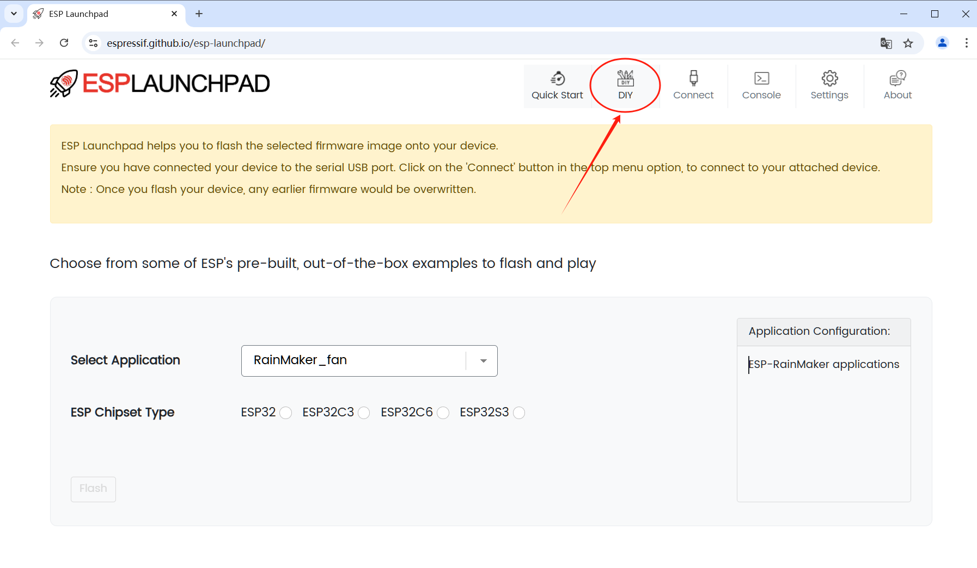

2) DIY page connection to the Connect development board COM serial port
Procedure:：
(1) Please click on the Connect menu (arrow position 1) in the upper right corner of the DIY page of the website.
(2) On the pop-up layer, select the COM serial port of the development board connected to the user's computer, as shown in the figure below arrow position 2 (USB Serial (COM12) - Paired), the COM port number here is for reference only, it will be different according to each person's development board.
(3) On the pop-up layer, click the Connect button to authorize, so that the user's development board COM serial port is loaded by the website browser.
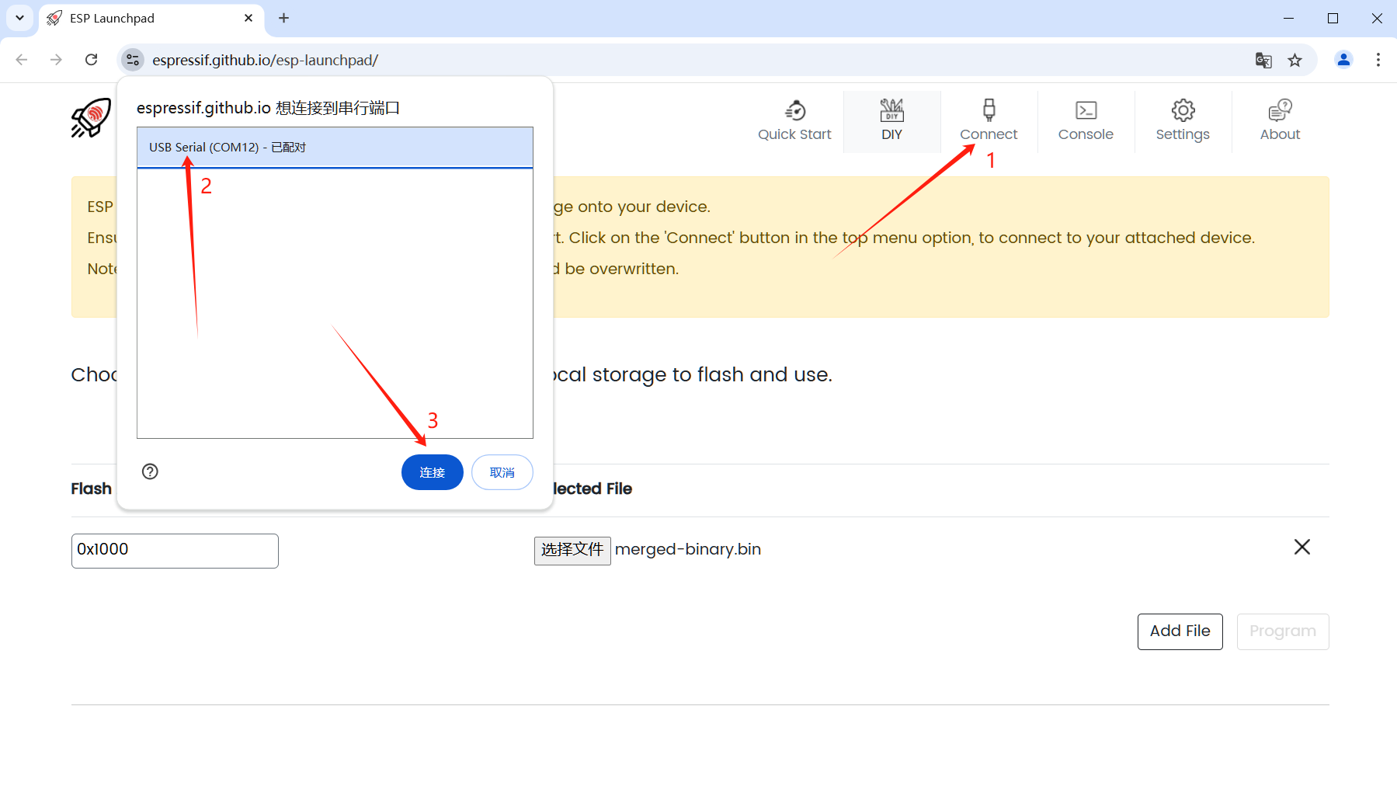
(4) Make sure that the COM serial port of the development board is connected
After the COM port of the development board is connected by the browser, the web page will display the words Connected to device: ESP32-S3, and the menu Connect will change to Disconnect, indicating that the COM port of the development board is successfully connected 。
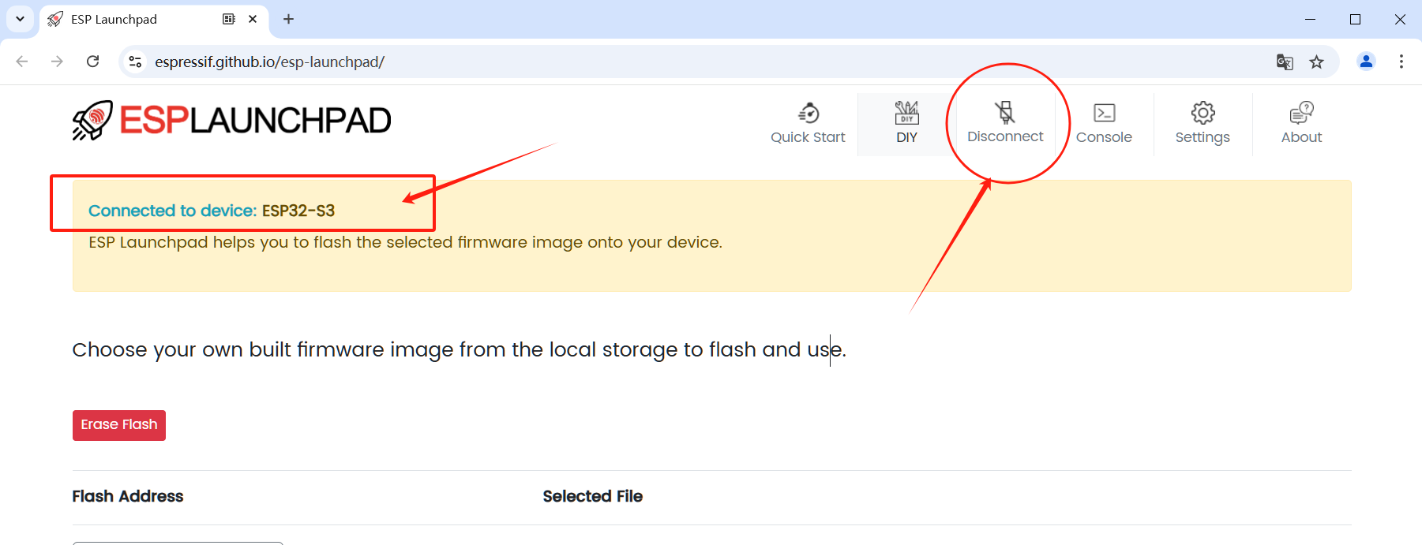

3) Load and set the corresponding version of the BIN firmware
1) The web page loads the corresponding bin firmware
Click the Select File button in the middle of the DIY page (Position 1 below), browse to the folder where the bin firmware is located on the computer, select the bin firmware file (Position 2 below), and then click the Open button (Position 3 below) to load the bin firmware on the web page.
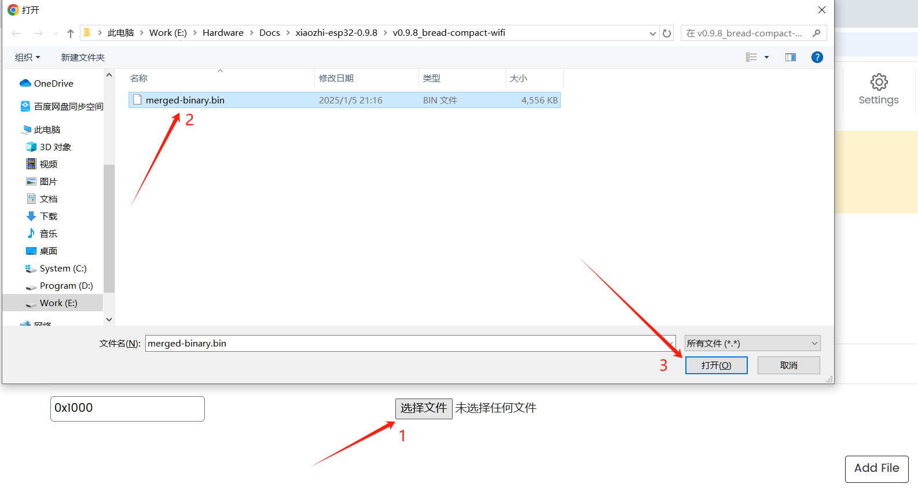
2) Set the start position of the burning
Steps:
Fill in 0x0 or 0 in the Flash Address (the start address of the flash store) as shown in the following figure.
Also, make sure you have seen the bin file you just loaded for position 2, if it doesn't show up, please re-import it by step 1).
Since the Ash AI firmware package has been merged into a bin package, i.e. merged-binary.bin, there is no need to add additional bin firmware.
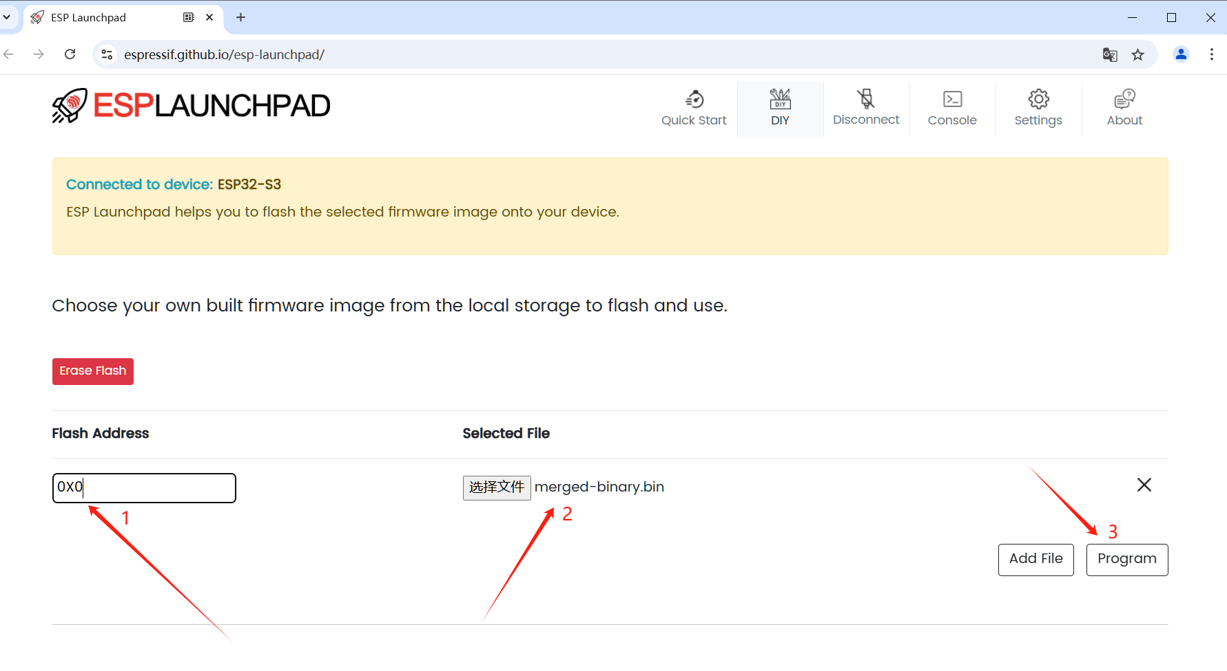

4) Burn the bin firmware and check whether the burning is successful
(1) Start burning:
Please click the Program button in position 3 above to start burning the firmware program, and the corresponding application firmware will be downloaded to the development board/device.
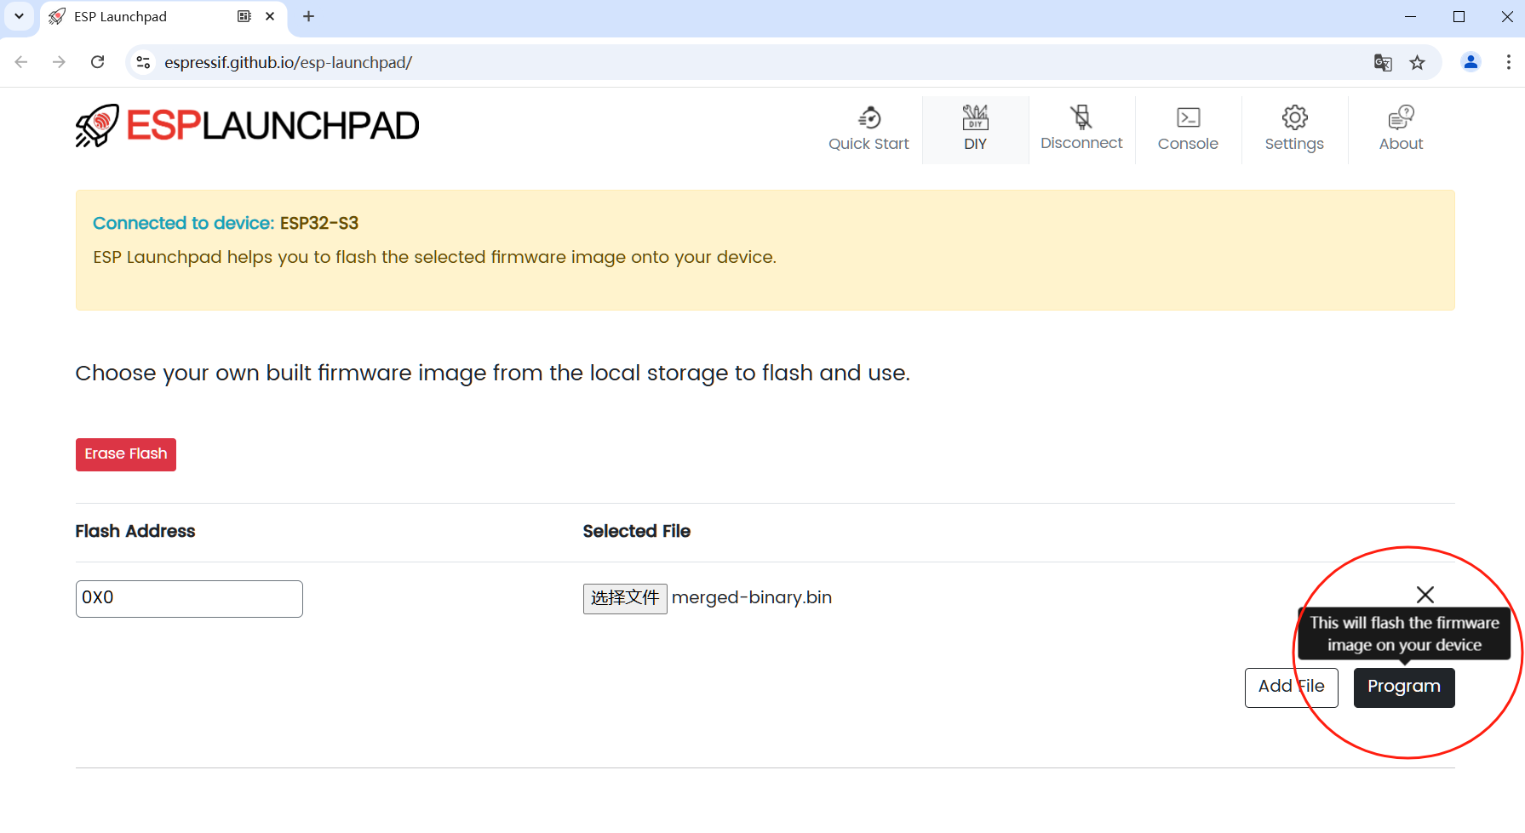
（2）The burning process is displayed
After starting burning, the web page will automatically jump to the Console command-line menu page, displaying the burning process as shown in the following figure
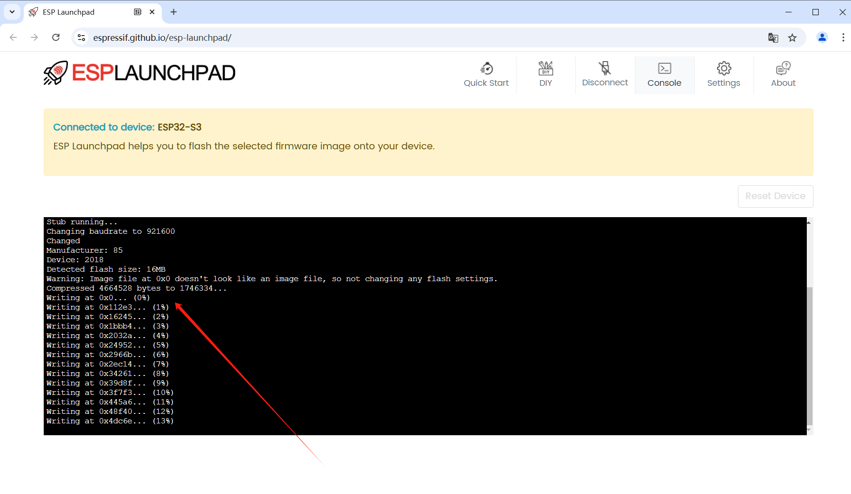
(3) Confirm that the burning is complete and restart
- The burning is complete
When on the black screen of the console it sees that the write is 100% complete and prompts to leave Leaving... After the prompt information, click the Restart device button on the right to restart the development board, and you can see that the program has been successfully burned.
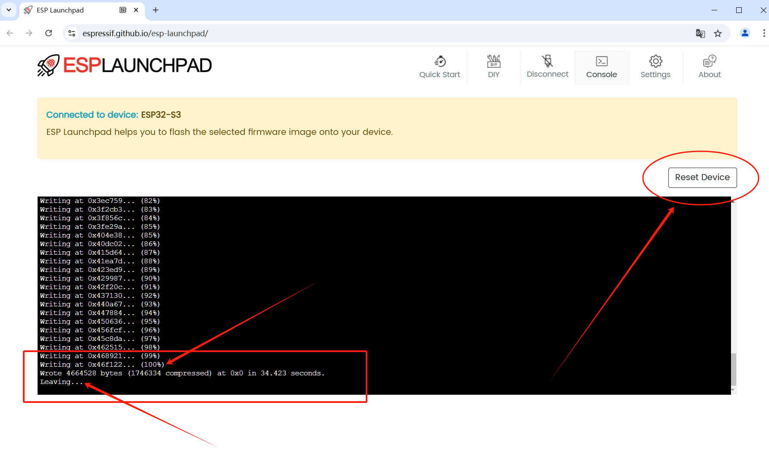
- Restart the device/board
After the firmware is burned, the device will not restart automatically, you need to restart the device manually, here please click the Reset Device button on the web page (position 1 in the figure below), and confirm again Click the Comfirm button (position 2 in the figure below), Confirm to restart the board to start running the firmware program you just burned.
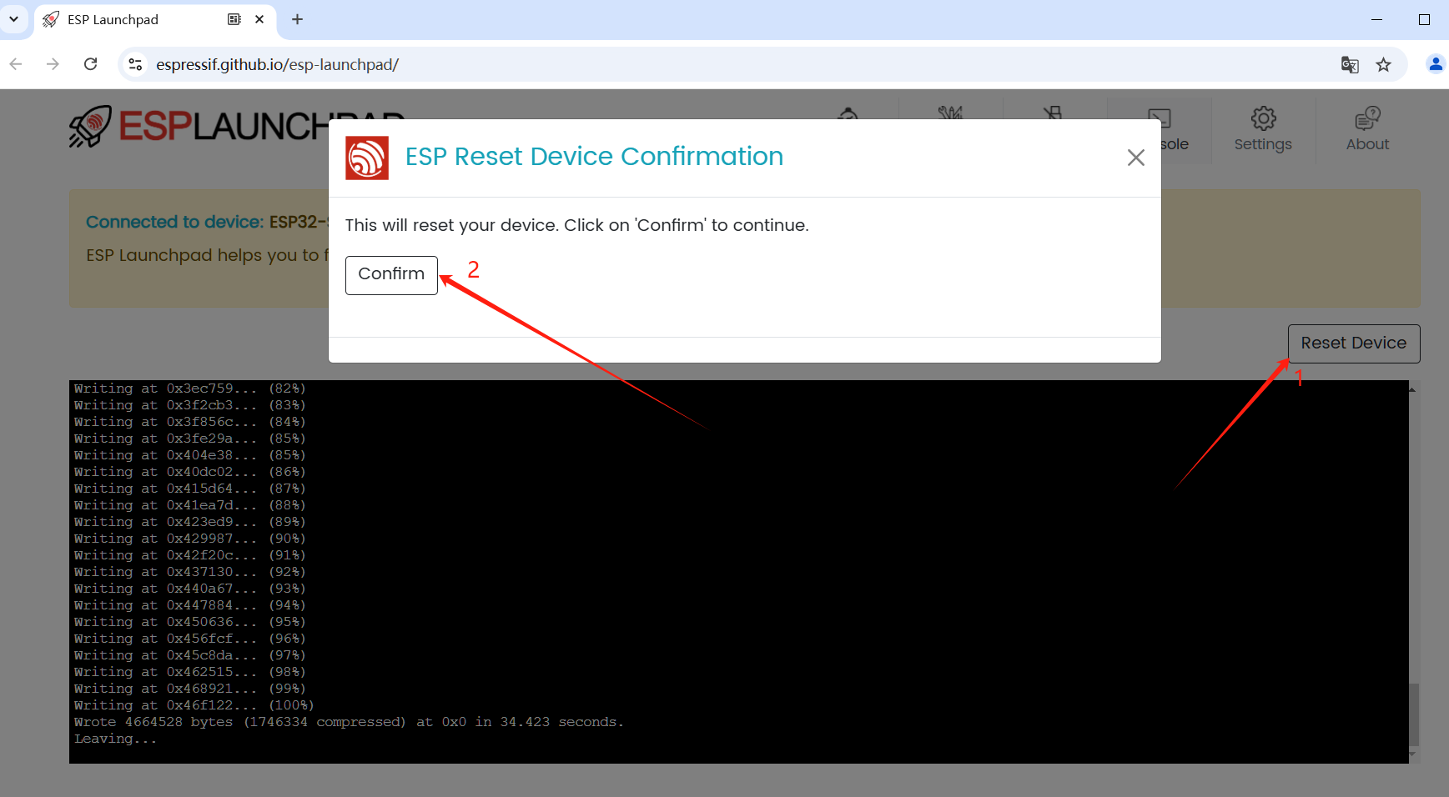

- The development board firmware program is running normally
After the development board/device is restarted, the serial port log of the Xiaozhi AI terminal firmware program will be loaded in the console, and the network card address and WIFI network distribution prompt will appear in the output log, indicating that the program is successfully programmed, as shown in the figure below.
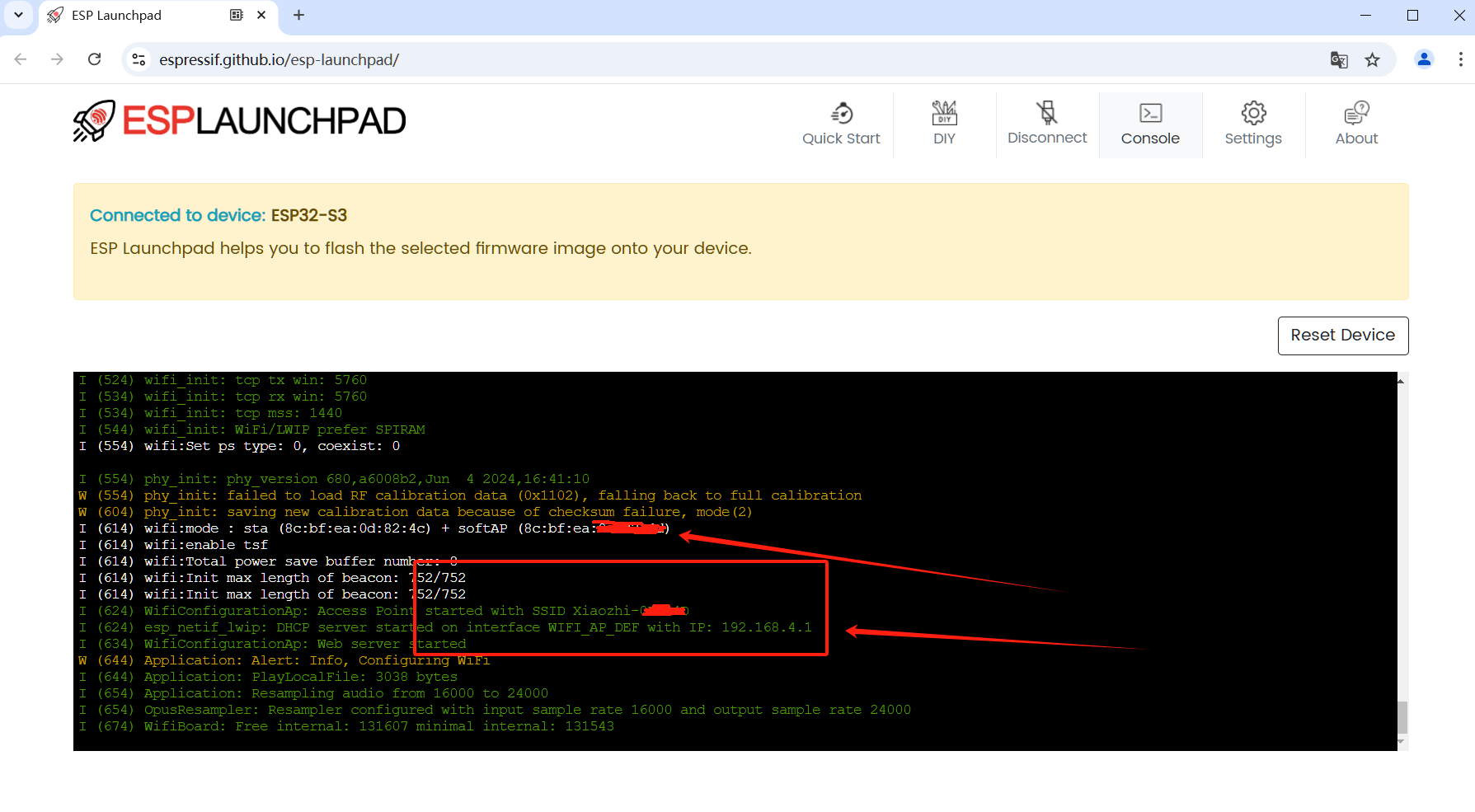

- Error Prompts and Exceptions

Q1: The development board cannot be connected?
The development board cannot connect to the browser, the pop-up layer option is empty, and cannot be loaded and displayed on the web page.
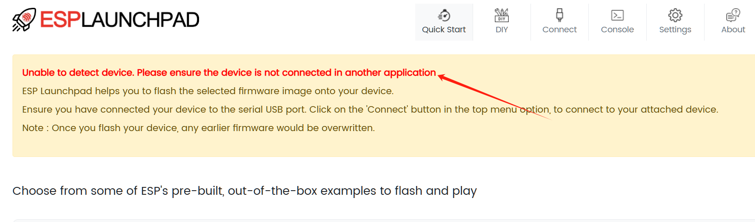

Q2: The Program burning button cannot be clicked?
The bin file has been loaded, but the Burn Program Firmware button is gray and cannot be clicked.
1) Generally, check whether the development board is connected to the computer browser, and display the words Connected to device: ESP32-S3 on the web page, if not, please click Connect on the menu to authorize the connection.
2) When the browser switches pages, in order to speed up the display, there will be cache, please click the browser menu to refresh the page, or press F5 or Ctrl+R to refresh it. After refreshing, if the selected file is not loaded, please reload it, or disconnect the board and connect it again, and then check whether the Program button appears. If you're still having trouble, try a different browser.
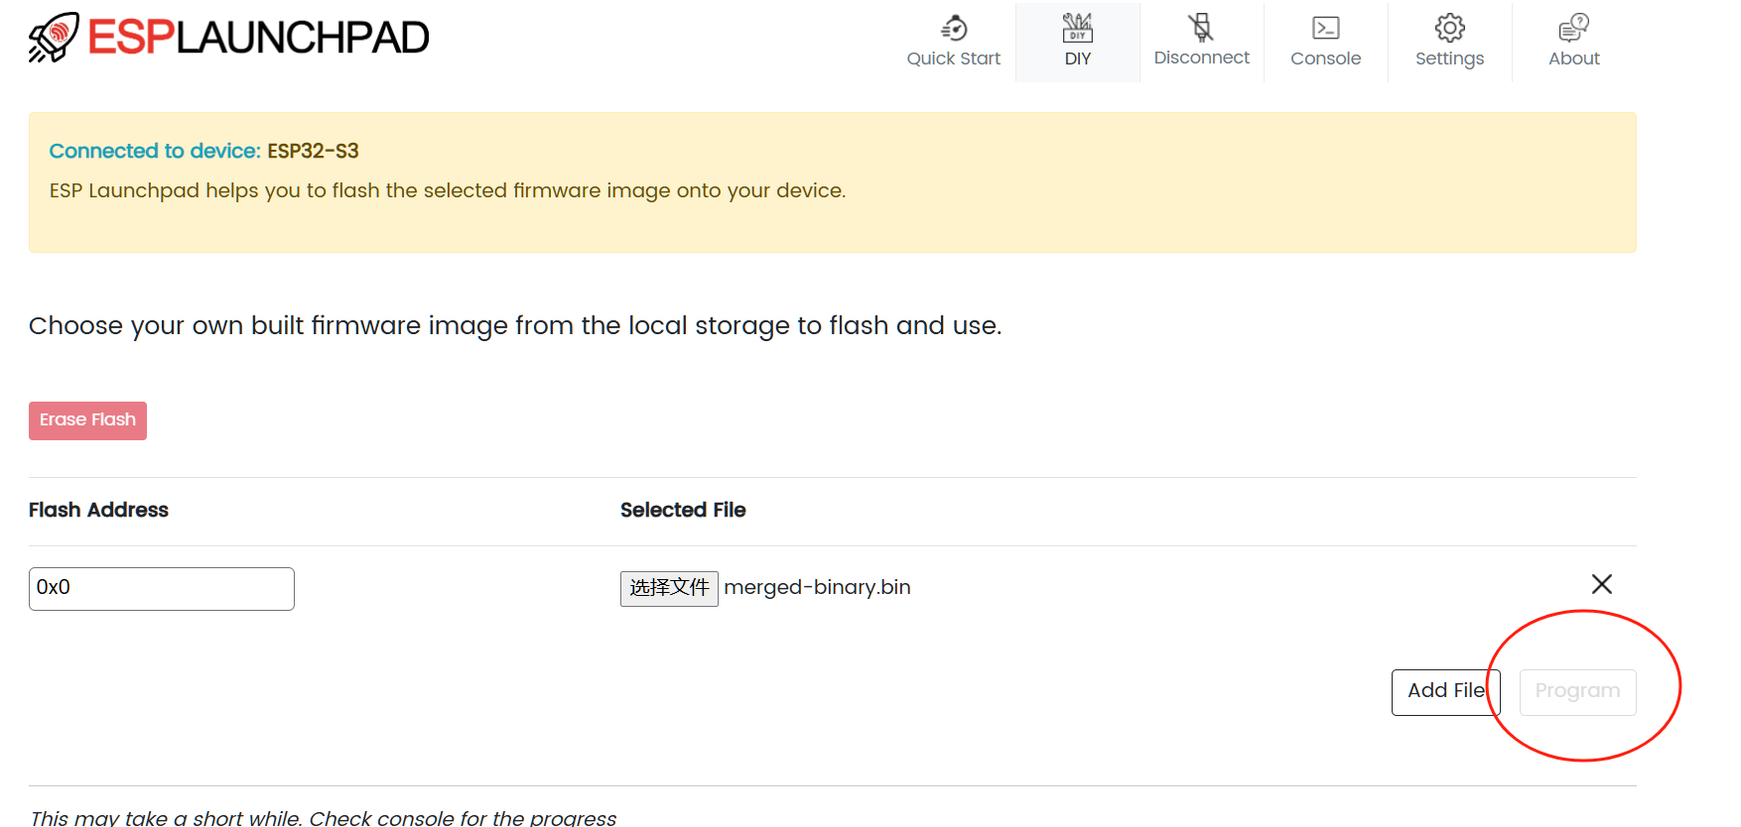

Q3: The program cannot run properly after burning?
After programming, the program keeps restarting on the black screen of the console, or an E-level error appears, which cannot work normally, considering that the user development board does not support the current programming firmware, please confirm whether the firmware of the corresponding development board is correct, please refer to the download firmware chapter in method 1.

For more abnormal problems not mentioned above, please go to the QQ group to discuss.
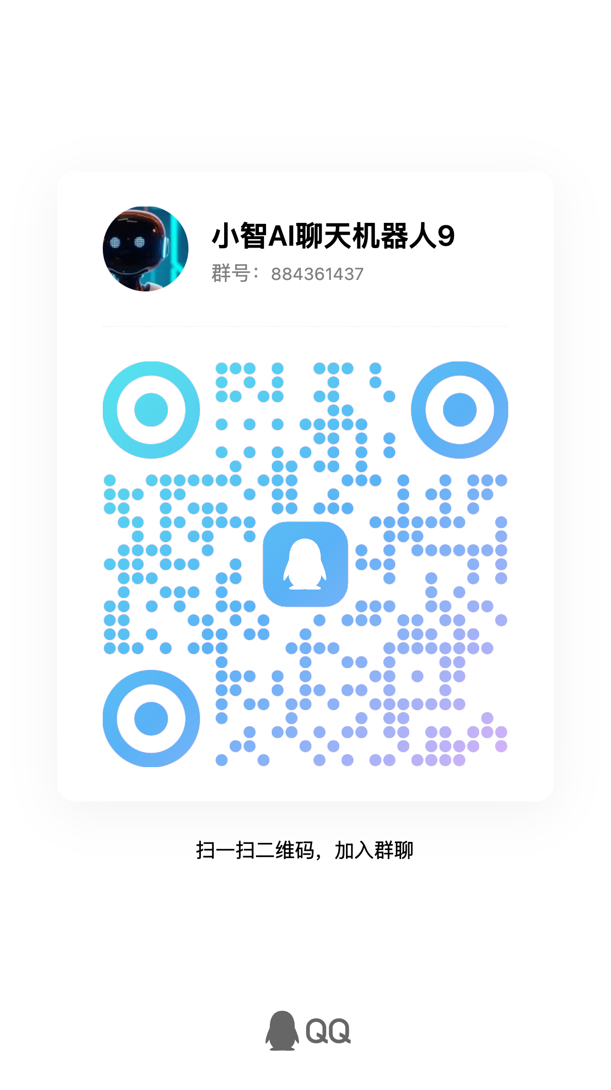

QA questions and others
- How do I enter boot mode?
Press and hold the BOOT key, then press the RST key (about 0.5s), release the BOOT button, set the board to enter the burning mode, you can try it repeatedly, the serial port will prompt the burning mode.
Auto program
DTR RTS->EN IO0
1 1 1 1
0 0 1 1
1 0 0 1
0 1 1 0

Attached: Download the Q part of the ESP32S3 development board
Qinheng USB to serial port driver download address, thank you for collecting and providing!
CH340 Series:
https://www.wch.cn/products/CH340.html
CH343 series:
https://www.wch.cn/products/CH343.html

